AFFIRMATION CONTROL MODEL FOR XML-BASED ELECTRONIC PROSPERING RECORD DESIGN

ABSTRACT
Cloud-based electronic health record (EHR) systems enable medical documents to be exchanged between medical institutions; this is expected to contribute to improvements in various medical services in the future. However, as the system architecture becomes more complicated, cloud-based EHR systems may introduce additional security threats when compared to existing singular systems. Thus, patients may experience exposure of private data that they do not wish to disclose. In order to protect the privacy of patients, many approaches have been proposed to provide access control to patient documents when providing health services. However, most current systems do not support fine-grained access control or take into account additional security factors such as encryption and digital signatures. In this paper, we propose a cloud-based EHR model that performs attribute-based access control using extensible access control markup language. Our EHR model, focused on security, performs partial encryption and uses electronic signatures when a patient document is sent to a document requester. We use XML encryption and XML digital signature technology. Our proposed model works efficiently by sending only the necessary information to requesters who are authorized to treat the patient in question.

EXISTING SYSTEM | PROPOSED SYSTEM
EXISTING CONCEPT:-  - Cloud-based electronic health record (EHR) systems enable medical documents to be exchanged between medical institutions;  - Cloud-based EHR systems may introduce additional security threats when compared to existing singular systems. | PROPOSED CONCEPT: -  - We propose a cloud-based EHR model that performs attribute-based access control using extensible access control markup language.  - Our EHR model, focused on security, performs partial encryption and uses electronic signatures when a patient document is sent to a document requester.
EXISTING TECHNIQUE:-  - Hashing Algorithm | PROPOSED TECHNIQUE:-  - Encryption Algorithm
TECHNIQUE DEFINITION:-  - A hash algorithm is a function that converts a data string into a numeric string output of fixed length.  - The output string is generally much smaller than the original data. | TECHNIQUE DEFINITION:-  - A mathematical procedure for performing encryption on data.  - Through the use of an algorithm, information is made into meaningless cipher text and requires the use of a key to transform the data back into its original form.
DRAWBACKS:-  - Hash collisions are practically unavoidable.  - When hashing a random subset of a large set of possible keys.  - Hash tables become quite inefficient when there are many collisions. | ADVANTAGES:-  - An encrypting algorithm scrambles the message and it can only be unscrambled with a key created at the same time.  - Cipher algorithms are either symmetric or asymmetric for encryption security. For example: Symmetric - the exact same key is used to encrypt and decrypt data.

SYSTEM ARCHITECTURE: 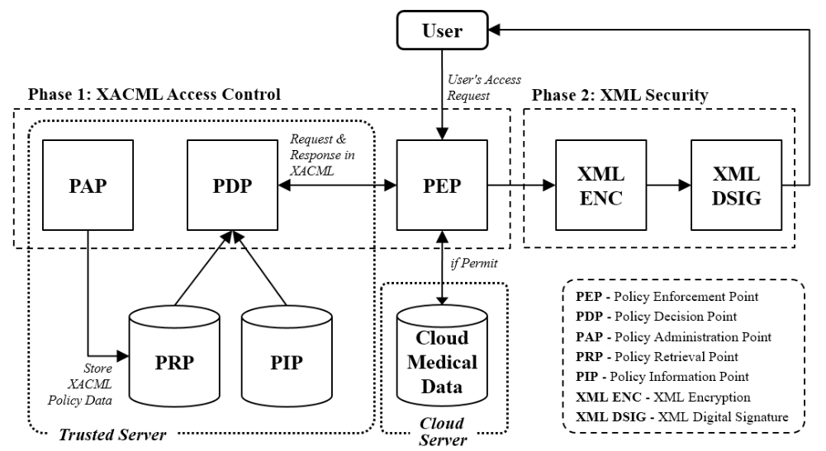
Fig: System Architecture

MINIMUM SYSTEM REQUIREMENTS
HARDWARE REQUIREMENTS
- PROCESSOR : DUAL CORE 2 DUOS.
- RAM : 2GB DD RAM
- HARD DISK : 250 GB

SOFTWARE REQUIREMENTS
- FRONT END : J2EE (JSP, SERVLET), STRUTS
- BACK END : MY SQL 5.5
- OPERATING SYSTEM : WINDOWS 7
- IDE : ECLIPSE

PROPOSED SYSTEM | FUTURE ENHANCEMENT
PROPOSED CONCEPT: -  - We propose a cloud-based EHR model that performs attribute-based access control using extensible access control markup language.  - Our EHR model, focused on security, performs partial encryption and uses electronic signatures when a patient document is sent to a document requester. | FUTURE CONCEPT: -  - We do know the encryption was shared key, symmetric stuff; but we don’t know exactly how it works which limits the practical applications.  - However, encryption built on machine learning alone is impressive enough to make us wonder where else encryption might go in the future.  - Any security model, cryptographic or otherwise, is conceptually an arms race between the adversaries that wish to subvert the technology and those that rely on the technology to secure their information.
PROPOSED TECHNIQUE:-  - Encryption Algorithm | FUTURE TECHNIQUE:-  - Cryptographic Algorithms.
TECHNIQUE DEFINITION:-  - A mathematical procedure for performing encryption on data.  - Through the use of an algorithm, information is made into meaningless cipher text and requires the use of a key to transform the data back into its original form. | TECHNIQUE DEFINITION:-  - As technology advances so does our ability to encrypt data, with neural networks now capable of learning how to keep data safe.  - With so much innovation at our fingertips, Davey Winder explores where else encryption might go in the future.
ADVANTAGES:-  - An encrypting algorithm scrambles the message and it can only be unscrambled with a key created at the same time.  - Cipher algorithms are either symmetric or asymmetric for encryption security. | EXTRAVAGENCE  - Visual cryptography (VC) is a method of encrypting a secret image into shares such that stacking a sufficient number of shares reveals the secret image.  - Shares are usually presented in transparencies.
ALTERNATE TITLE
1. Privacy-preserving Attribute-based Access management Model for XML-based Electronic Health Record System
2. Protection safeguarding Attribute-based Access administration Model for XML-based Electronic Health Record System

